**MASK Online Shop**

In the project we have modules like

**Home page:** The home page contains the list of all the products on the website. On the top below the nav bar we have carousel displaying information about the sales.

On the home page we have the logo and the add to basket and wish list. By clicking on the add to basket symbol user can see the list of items added to basket from there he can also delete the products in the basket and proceed to checkout where the user will be asked to login to provide security after login he will prompted to fill the information like his name, address, phone num etc which will be saved in the database for next time.

In this page we have one section for offer of the week, one section for top selling products.

**Nav bar:** In the nav bar we have links to Home, All Products, Product Admin, Category Admin. The links will appear based on the login role.

We also have the links for the Register and Login where the new user can register and the registered user can login.

For User: Home, All Products

For Admin: Home, All Products, Product Admin, Category Admin.

**Footer:** In the footer we have many hyperlinks for about, help and contact related services.

**All products page**: In all products page we will have two sections in the left section we have filters for selecting the different categories of products. In the right section we have list of products based on the filter selected. we have search option also. Products names are hyperlinks by clicking on it will redirect the user to individual product page where the user can zoom the image check the description also. If user wish to buy he can place the order by clicking Add to basket. It will redirect the user to checkout page.

**Individual Product Page:** In this page user can zoom the product and see the picture clearly. This page also contains the detailed description of the product.

**Product Admin Page**: This page contains the details of the products and the options for the admin to create, delete and edit a product.

**Product Category Page:** This page contains the details of the categories of products and the options for the admin to create, delete and edit a product category.

**Authorization and Authentication module:**

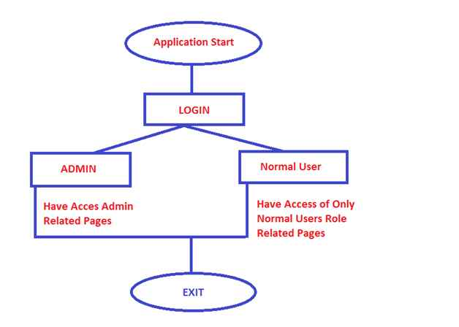

**Authentication:**

Check for the Valid User. Here the question is how to check whether a user is valid or not. When a user comes to a website for the first time he will register for that website. All his information, like username, password, email, and so on will be stored in the website database. When a user enters his user ID and password, the information will be checked with the database. If the user has entered the same user ID and Password as it is in the database, then he or she is a valid user and will be redirected to the website home page. If the user enters a User ID and/or Password that does not match the database then the login page will give a message, something like “Enter valid Name or Password”. The entire process of checking whether the user is valid or not for accessing the website is called Authentication.

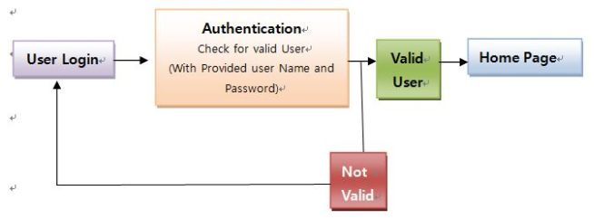

**Authorization:**

Once the user is authenticated, he needs to be redirected to the appropriate page by his role. For example, when an Admin is logged in, then he is to be redirected to the Admin Page. If an Accountant is logged in, then he is to be redirected to his Accounts page. If an End User is logged in, then he is to be redirected to his page.

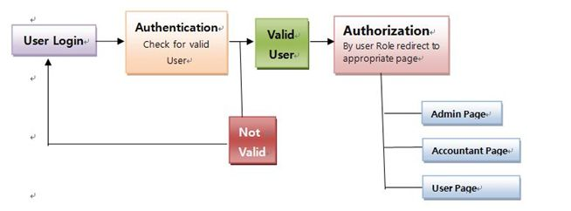

To make the website more secured we decided to create different roles so that the person who logins into the website will have access to different operations based on the roles he has.

We have implemented two roles like user and admin.

User will have only permission to view the products on the website.

Admin will have access to all the operations like create, edit, delete.

By creating the roles, we can authenticate the users and authorize the users based on the roles.

In this module every user must register to shop the products from the website. Whenever the user proceeds to checkout he will be asked to enter the name, address, phone number. Information entered by the user will be stored in the database for the next time. Once user is done with the shopping, he can logout. The information given by the user during the registration will be saved in the database for the purpose of validation.

**Add to basket module:** In this module we have designed the view to display the image of the product, product name, quantity, price, line total for every product. So that the user can see the details of the added products and the total amount of all the products in the basket.

In this view we also have the option of deleting the added product from the list.

If the user is happy and wanted to shop the products, he can proceed to the checkout by clicking on the checkout button. Then the user will be prompted to login before proceeding to checkout. If he is the new user, he should enter the name, address, phone num etc. which will be saved in the database for next time. If he is already registered all the details will be filled from the database. Then checkout process will be done, and the order Id will be generated and displayed to the user. So that he can keep track of the shipment based on his order Id.

**Checkout Module**: In this modulewe have designed a viewto get the information from the user to proceed to checkout. That user information will be stored in the database for the future use.

**Product Filtering:** In this module we will have the list of product categories. By clicking on the All Hyperlink in the product category we will get the list of all the products on the website. By clicking on the individual category, we will get only the products in that category.

**Search the Product:** In this module we will have the search box to search for the specific product based on the name of the product.

**Rating & Review:**  In this module we have provided the user to rate and review the products that he has purchased.

**Wish List:** Inthis module the user can add the products which he is interested into the wish list from there he can proceed to the checkout